OSGI Config

4 type of fields🡪text(String,int,long,short),checkbox,array,dropdown

2 type of osgi config node🡪 nt:file sling:OsgiConfig(why this is, we mayn’t have prod access to change on server so using this we cn change)

Nt:file—apps/system/congig copy the file and paste in proj/config-auth or confi

Open file and edit as req osgi values will be updatred

sling:OsgiConfig – create node of type sling:OsgiConfig with name as PID(present in bundle open ur bundle in config info copy paste)

here add prop using field we have

method name is key, value we give

serviceName-String type- AEM DEMO (display AEM DEMO in bundle or in htl) likwwise add all prop

@designate will generate metatype for the objectclassDefinition

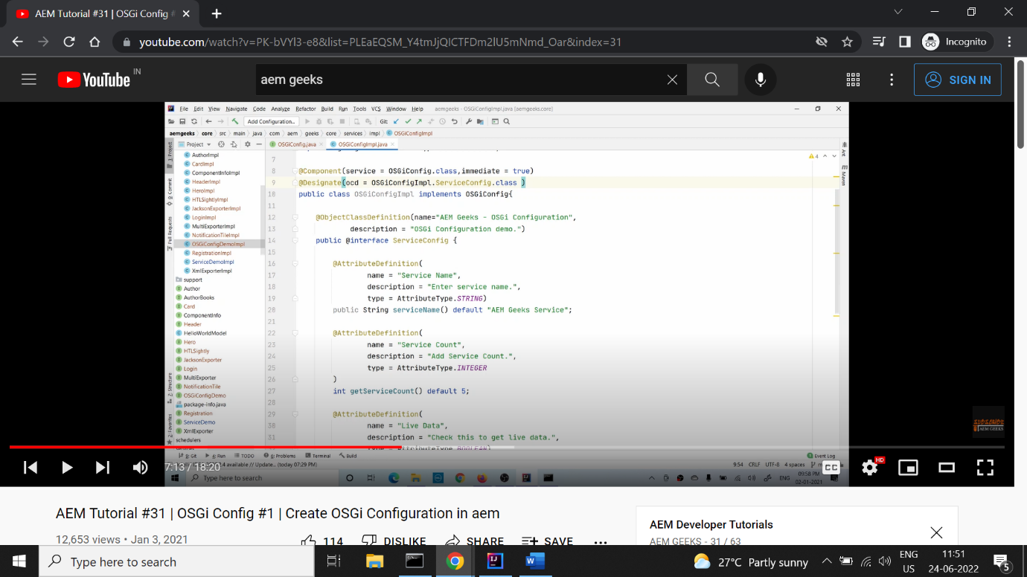

@desinage(ocd=OSGIConimpl(class hv impl) .serviceCongif(this is interface hav mthods)

@ObjClsDef- name—name if the bundle,

@AttDef()-fields in the config , serviceName() is method name, type define type of field

@Attdef() String[] getCOuntries() – way of define array

@Attdef(name,des,options={@option(label=”author” value=”author”), @option(label=”publish” value=”publish”)},type=AttType.STRING)

String getRunMode() def “author”; ---- way of dropdown

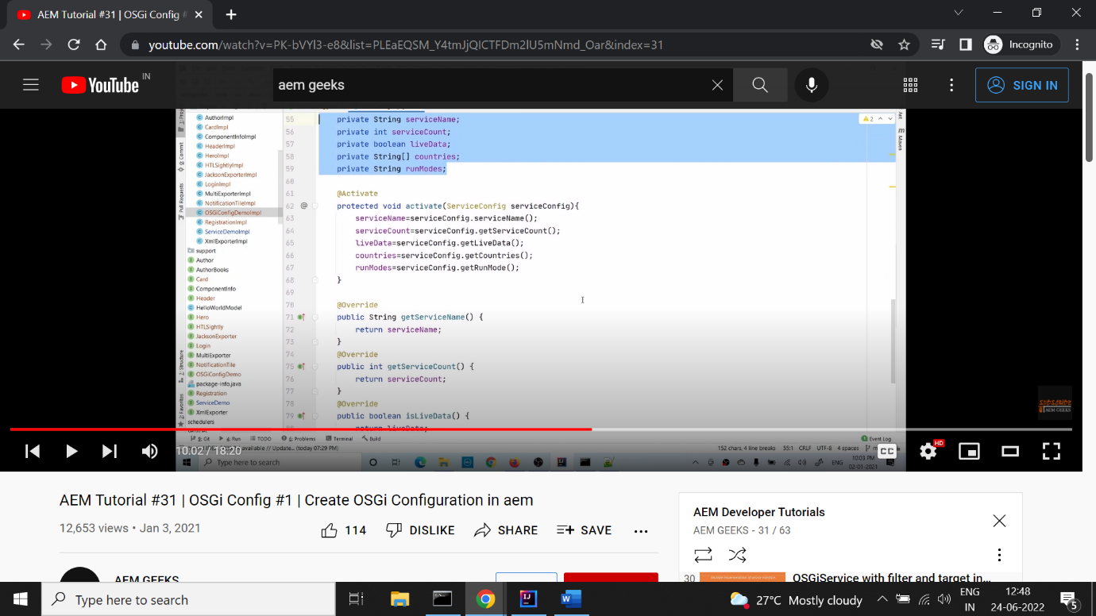 .

We can use this values anywhere

@activate helps to load the values whenever bundle is installed

* Calling osgiser in sling

---------------------------------------------------------------------------------------------------------------------------

Creating osgi config as separate file and calling in any backend compo like service,compo, schedular,etc

* OSGICOnfig

* Implement above cobfig

@designate here it is impl’ing config of that class

* Create a sling model

\*htl

* OSGI FACTORY🡪

------------------------

I want to post something in different social media, rather than writing different osgi service using factory we can create different instances from same config

Add factory=true in @designate

We can use this config in any backend compo

* Demo

after build open web config searvh aem geeks osgi factory config(this is name of config) we can see + symbol now give values and can add any

Now we are making a list of total config here allowing us to create different instance, can add any no of config in list, fr seeing o/p showing in compo

Have a list of factry config clas

Cardinality=helps in listening to the service as soon as service is available it will listen, MULTIPLE=listens everytime, policy=DYNAMIC – hleps to find itself for unbindOSGI.. method

Why using bundOSGI… method instead of activate method

The activate execute 3 times if we create 3 instance making a drawback of refreshing the list fr everytime activate executes, so finaly only the last executed will be present in list

@reference is placed to method using which class service

* Model

